Hiyab Mengisteab

Statistic Data Mining Task 3

B. Purpose of the Data Analysis

B1. Research Question
What are the key housing features that significantly influence the sale price of a house, and to what extent can these features predict the final house price?

B2. Goal of the Analysis
The goal is to build a multiple linear regression model that can predict a house’s sale price (Price) using key property and neighborhood features. This model can be used by real estate firms and appraisers to estimate home values with more accuracy.

C. Purpose of PCA

C1. PCA for Regression Preparation
- Why PCA
  - Principal Component Analysis (PCA) helps reduce the number of features while keeping most of the original information. A smaller set of uncorrelated variables (principal components) is used to explain most of the variance in the dataset, which Simplify the regression model and improves model performance and interpretation.
- C2. PCA Assumption
  - PCA assumes that the principal components are linear combinations of the original variables and that the dataset is scaled and continuous (since it relies on covariance/correlation).

D. Data Preparation for Linear Regression

D1. Continuous Variables
To predict Price, we will use the following continuous variables:
- SquareFootage
- NumBathrooms
- BackyardSpace
- CrimeRate
- SchoolRating
- AgeOfHome
- DistanceToCityCenter
- EmploymentRate
- PropertyTaxRate
- RenovationQuality
- LocalAmenities
- PreviousSalePrice

D2. Standardize Variables

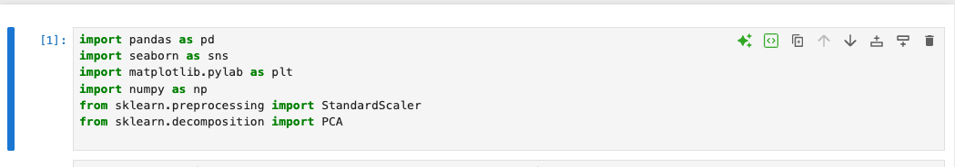

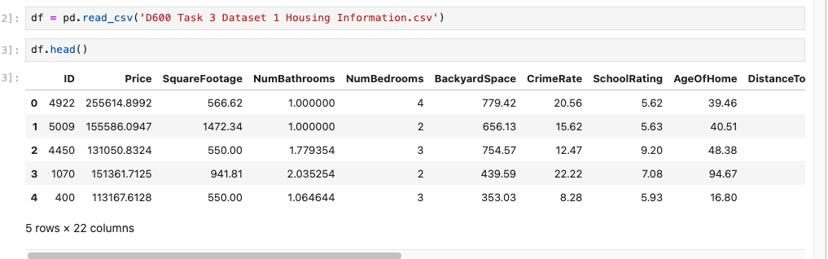

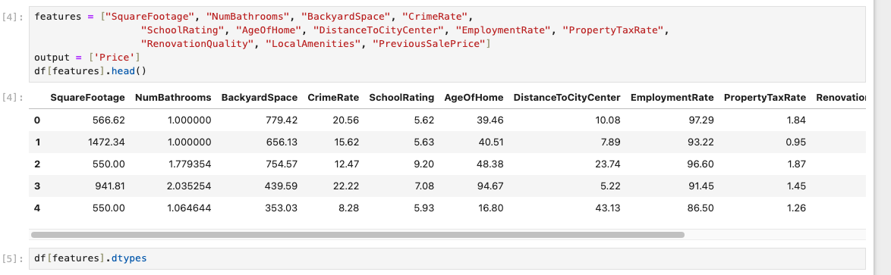

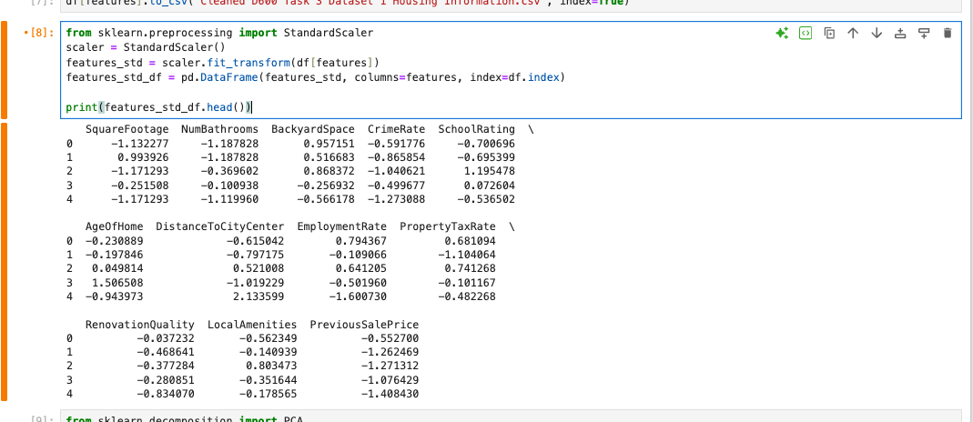D3. Descriptive Statistics

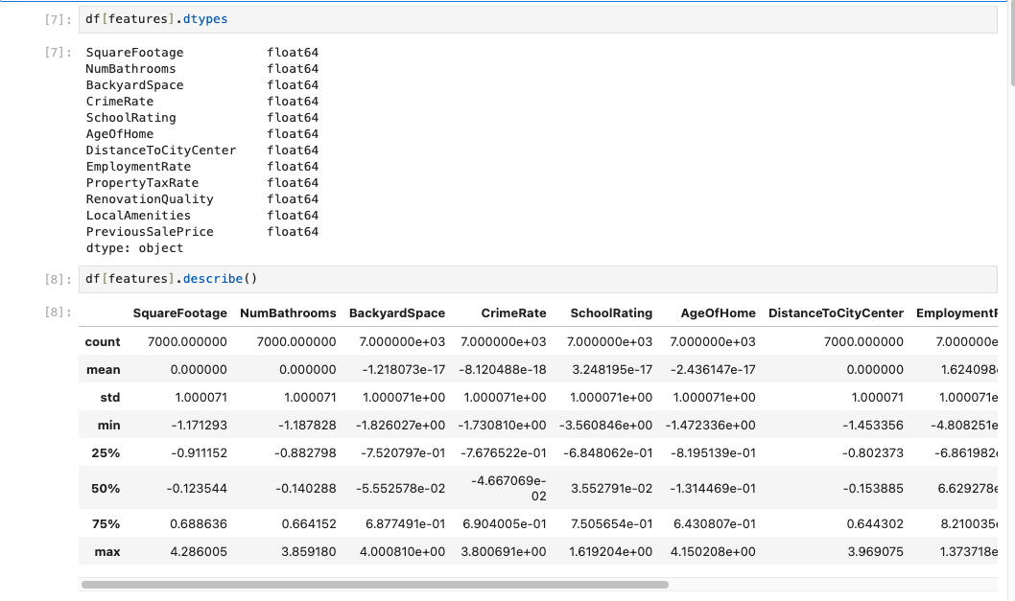

E. Perform PCA

E1. Principal Components Matrix

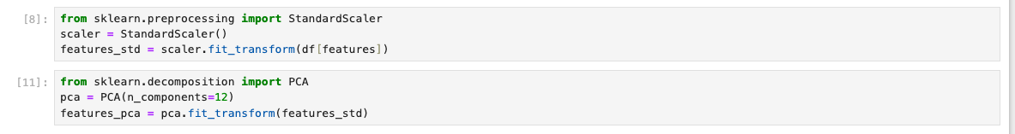

E2. Determine Number of Components, and K-mean/elbow rule

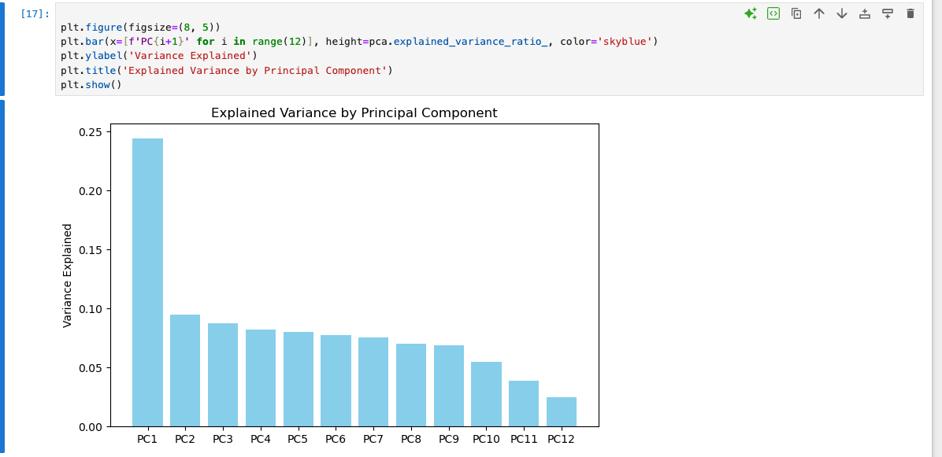

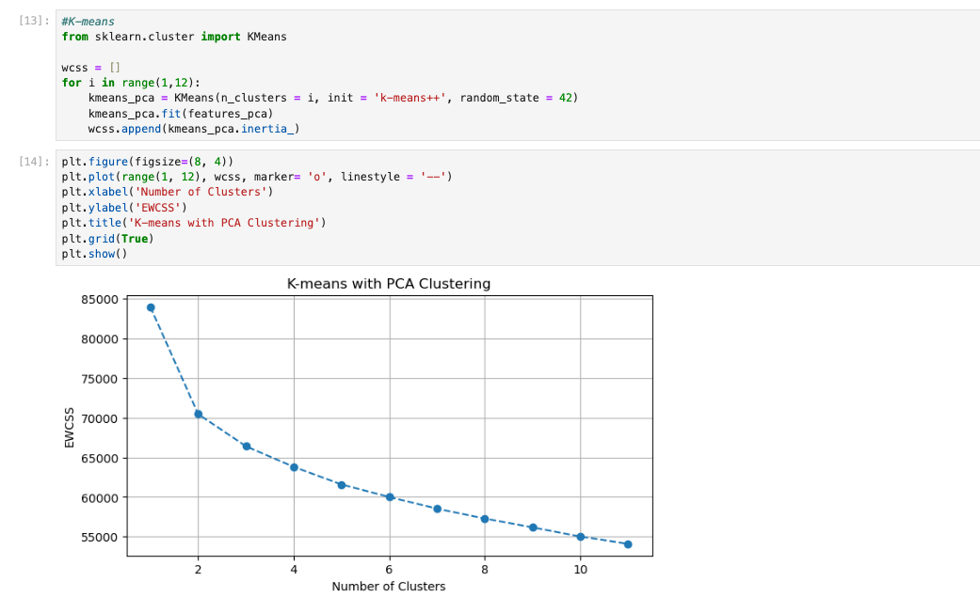
- Elbow rule = kink comes at PC2

E3. Variance of Each Component
E4. Summarize Component:
- 12 components were retained for this analysis
- Based on the data, this means that the first 12 components combined capture 100% of the structure/variance from the data
  - Principal Component 1 (PC1) accounts for 24.46% of the total variance — the most significant component.
  - The first 4 components together explain approximately 50.96% of the variance:
  - PC1 to PC4: 0.2446 + 0.0951 + 0.0877 + 0.0820 ≈ 50.96%
  - The first 8 components cumulatively explain about 91.18% of the variance:
  - PC1 to PC8: ≈ 0.9118
  - All 12 components explain ~100% of the variance (sum: 0.99999901), as expected when using PCA on standardized features.
- The Elbow Method (plotting inertia vs. number of clusters) showed a clear bend (“kink”) at k=2, suggesting that 2 components is the optimal grouping for your data.

F. Data Analysis and Results

F1. Train/Test Split

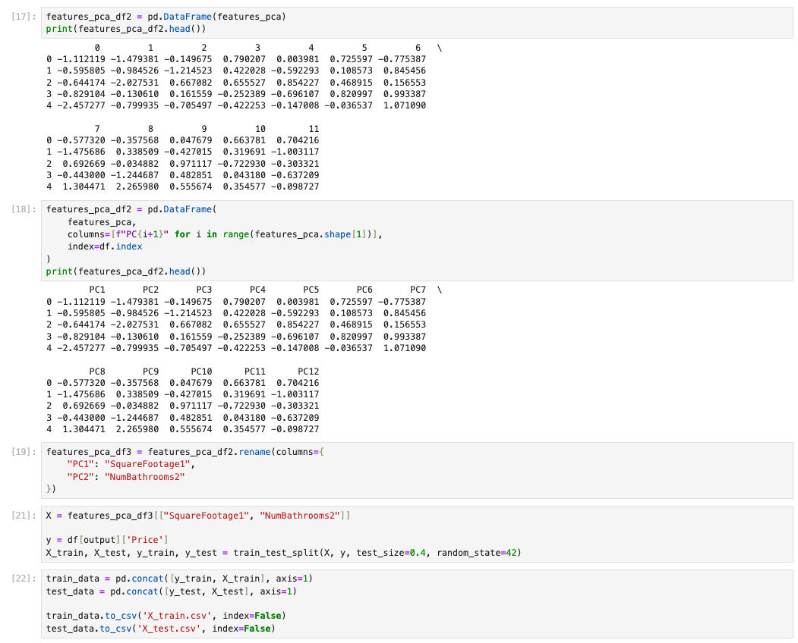

F2. Train Regression Model

Linear Regression

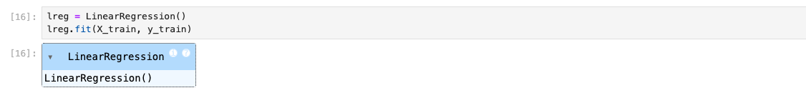
- Backward Elimination
- 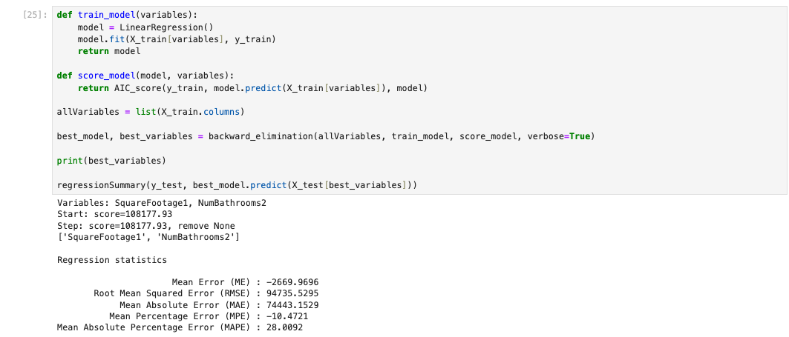
Extract:
- Adjusted R², R², F-statistic and p-value
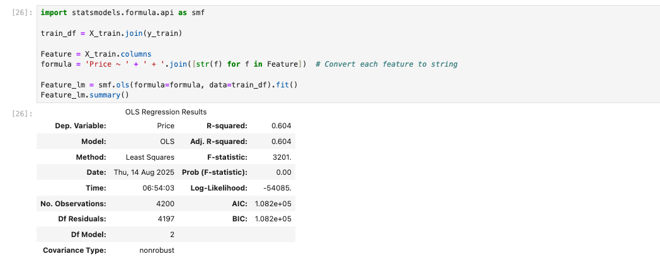
- Coefficient estimates and p-values
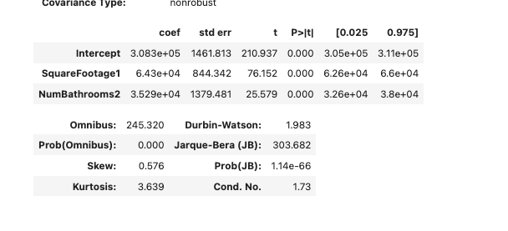
- Validation
- 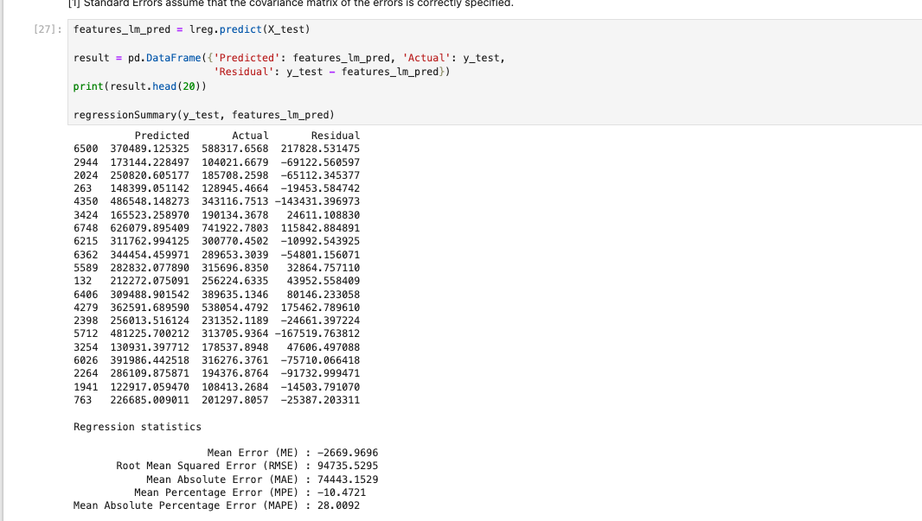
Detail Summary:
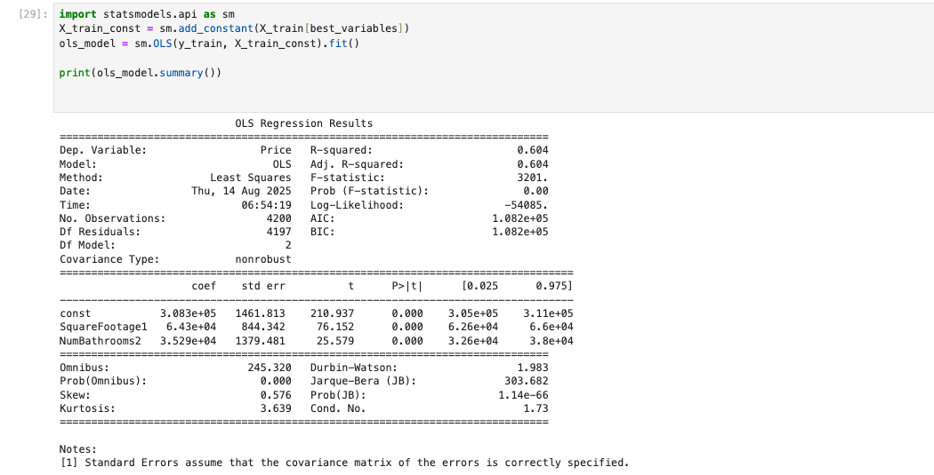

F3. MSE on Training Set

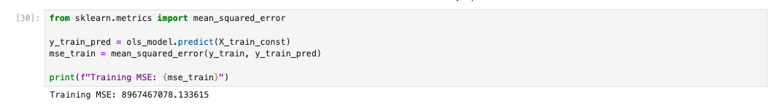F4. Test Set MSE
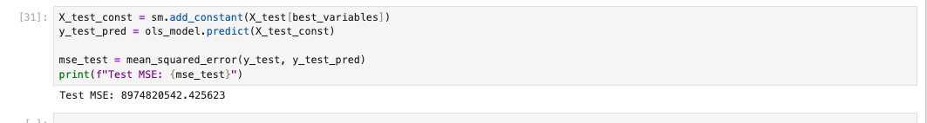

G. Summarize your data analysis by doing the following:
  - List the packages or libraries you have chosen for Python or R and justify how each item on the list supports the analysis.
Packages or libraries | Explain use
Pandas | Used for data manipulation and analysis using DataFrames.
scikit-learn (sklearn) | - Used to build machine learning and model development.  - train_test_split: Splits data into training and testing sets.  - LinearRegression, Lasso, Ridge, LassoCV, BayesianRidge: Different types of regression models for prediction and analysis.  from sklearn.preprocessing import StandardScaler: Standardizes features (zero mean, unit variance). Preparing data for ML models (especially for PCA or regression).  from sklearn.decomposition import PCA: Principal Component Analysis for dimensionality reduction. Reduce high-dimensional datasets to fewer components while preserving variance.  from sklearn.metrics import mean_squared_error: Measures the average squared difference between predicted and actual values (used to evaluate regression model performance).
Seaborn and matplotlib | Plotting graphs and visualizations
NumPy | Numerical operations, handling arrays, math functions (e.g., mean, std, etc.).
dmba | A specialized library for business analytics for summary review and optimization.  - regressionSummary: Provides a concise summary of regression performance.  - exhaustive_search: Searches all possible combinations of predictors to find the best model based on a scoring metric.  - exhaustive_search, backward_elimination, forward_selection, stepwise_selection: Feature selection techniques.  - Adjusted R²: R² adjusted for the number of predictors (penalizes overfitting).  - AIC (Akaike Information Criterion): Model quality relative to other models.  - BIC (Bayesian Information Criterion): Similar to AIC but more heavily penalizes complexity.
statsmodels.api | Provides functions for statistical modeling. Used for building OLS (Ordinary Least Squares) regression models, accessing model results, statistical tests, etc.
statsmodels.formula.api | Provide a formula-based interface to statsmodels. Used for creating statistical models using R-style formulas (e.g., y ~ x1 + x2).
sklearn.metrics | For scikit-learn (a machine learning library). Used for evaluating model performance by calculating the Mean Squared Error (MSE) between actual and predicted values.

  - Discuss the method used to optimize the model and justification for the approach.
  - To optimize the model, I applied the backward elimination method. This technique systematically removes variables that do not contribute significantly to predicting housing prices. Specifically, it starts with all available predictors and eliminates the one with the highest p-value at each step—indicating the least statistical significance—until only variables with meaningful contributions remain. This approach is effective because it helps simplify the model without sacrificing accuracy, improving interpretability while retaining key predictors. Based on the results, the final model retained the following variables, which had the greatest impact on house pricing:
    - SquareFootage1
    - NumBathrooms2

These predictors showed statistically significant relationships with housing prices, making them the most relevant PCs for the linear regression model.
  - Discuss the verification of assumptions used to create the optimized model.
  - Predicted vs. Actual Values: To verify the assumptions and evaluate the performance of the optimized linear regression model, I conducted a validation process comparing the predicted values, actual values, and residuals (the difference between predicted and actual values). This comparison helped assess both the accuracy of predictions and whether the residuals behaved consistently with linear regression assumptions.
  - Model Optimization Process: I applied a backward elimination technique to determine the most influential subset of variables by minimizing an information criterion. The results indicated that the two components should both be necessary for achieving the most effective linear regression model for predicting house prices.
  - Summary of Statistical Review: Using the regression summary output (e.g., from statsmodels), I examined key statistical measures such as p-values to determine the significance of each predictor. The analysis confirmed that the retained predictors were statistically significant and contributed meaningfully to explaining variations in housing prices. The two variables had low p-values, which explained why none were eliminated during optimization.

  - Provide the regression equation and discuss the coefficient estimates.
- The estimated multiple linear regression equation based on the provided coefficients is:
    - Predicted Price=308,300+64,300⋅SquareFootage1+35,290⋅NumBathrooms2
    - Each coefficient in the equation represents the expected change in house price for a one-unit increase in the corresponding feature keeping all things constant.

Term | Coefficient | Interpretation
Intercept | 308,300 | This is the baseline predicted price for a property whose PC1–PC6 scores are all zero. It represents the model's starting point before adjustments for the principal components keeping all things constant.
SquareFootage1 | +64,300 | PC1 has the largest positive effect on price. A one-unit increase in PC1 raises predicted price by $64,300, keeping all things constant.
NumBathrooms2 | +35,290 | PC2 also has a positive and substantial influence on price. A one-unit increase adds about $35,290 keeping all things constant.

5. Discuss the model metrics by addressing each of the following:
• the R² and adjusted R² of the training set
    - R-squared (R²): 0.604: This means that approximately 60.4% of the variation in housing prices can be explained by the model’s independent variables (e.g., square footage, number of bathrooms, crime rate, etc.).
Even though this is not extremely high, this indicates a moderate level of explanatory power — the model captures nearly half of the patterns driving home prices.
    - Adjusted R-squared: 0.604: The Adjusted R² accounts for the number of predictors in the model and adjusts for the potential inflation of R² when more variables are added. A value of 0.604, which is equal to the R², suggests that most variables in the model contribute meaningful information. The model is not overfitted with unnecessary predictors.

• the comparison of the MSE for the training set to the MSE of the test set
    - Mean Squared Error (MSE) measures the average of the squares of the errors—that is, the average squared difference between the actual and predicted values. The Test MSE is slightly higher than the Training MSE. This is an encouraging sign because it shows that the model is not overfitting—it generalizes well to new data. The similarity in values suggests that the model performs consistently on both the training and test sets.
      - Training MSE (≈ 8.96 billion)
      - Test MSE (≈ 8.97 billion)
6. Discuss the results and implications of your prediction analysis.
  - The comparison between the training and test MSE values suggests that the model is both stable and reliable. The minimal difference between the two metrics indicates that the model generalizes well to unseen data and is not overfitted to the training set—an important characteristic of a well-optimized regression model.
  - Additionally, the backward elimination process helped identify the most impactful predictors of housing price. These key variables are:
    - SquareFootage1
    - NumBathrooms2
    - These features demonstrated the strongest influence on home prices, offering valuable insights into the primary drivers of value in the housing market. This information can be useful for both real estate investors and policymakers when evaluating property development or pricing strategies.
7. Recommend a course of action for the real-world organizational situation from part B1 based on your results and implications discussed in part E6.
    - Based on the objective outlined in Part B1, which was to identify the key housing components that significantly influence sale price, we successfully pinpointed the most impactful variables using the backward elimination method. The key features identified are:
    - SquareFootage1
    - NumBathrooms2
    - Furthermore, the model—trained and tested on selected attributes—was able to explain approximately 60.4% of the variation in housing prices, as indicated by the R-squared value. Combined with the model’s low mean percentage error, these insights provide a reliable foundation for real estate businesses to develop competitive and data-driven pricing strategies in the housing market.
    - This means that with the model, businesses can use Square Footage and Number of Bathrooms as the primary predictors of housing prices. In the linear regression framework, these two components are shown to have the strongest explanatory power for price variation, meaning that as Square Footage increases or as the Number of Bathrooms increases, the model predicts a corresponding change in the estimated house price. By relying on the provided model, real estate firms, developers, and investors can create pricing strategies, forecast market values, and assess the impact of property features on overall valuation. This streamlined model also simplifies decision-making, as it identifies the most critical drivers of housing prices without unnecessary complexity from less influential variables.

Reference:
- External resources not used in this submission

